**Session: 5**

Date: 2 / 4 / 22

What Happen:

Elicitation

* What problems?
* What are ways your product is better or different
* Not just the investor
* The act of asking the questions

Project sponsor – UTD Dr. J

Scope – Decide meets the requirements

* Have the whole scope
  + Then phase scope
* Milestone
  + Delivery dates
* YouTube link
* Game architecture diagram

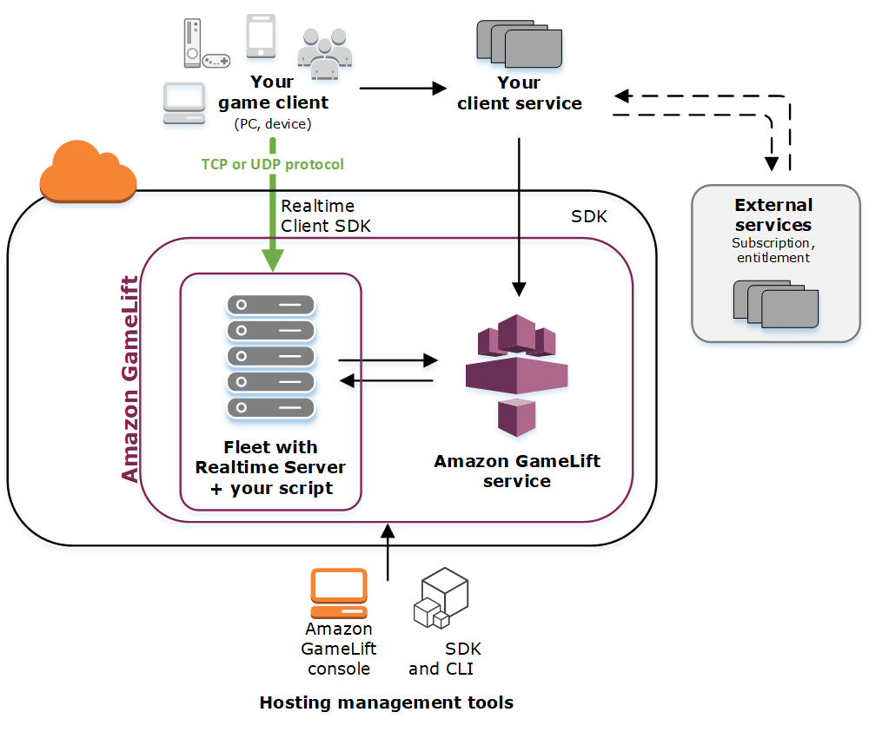

* How are you planning to design it
  + What is the system
* Midterm feedback
  + Project Proposal deadline
* Document – Version control
  + Simple Table
  + Important for the higher ups
    - The document keeps up to date
* Project document
  + Milestones
  + Milestone table
    - Serial number, description, who is working on the milestones (resources)
    - A way to brief people who are coming on the
* Work on the Project management document
* Work on the GDD
* Don’t overthink the project document
  + Can be simple if just work on
  + Gam-chart (Some document)
  + Having a deliverable
* A good project document can be used as the presentation

Next session:

* Meeting in person at Evan apartment
* Progress report on documents
  + Project Management
  + GDD
  + Project Architecture
* Progress on Godot
* Progress on Arena
* Progress on character movement
* Progress on character creation